ARAVALI HILLS
Land Degradation Analysis

Combined Deliverable 1 & Deliverable 2 Report
Rajasthan, India · 5 Districts · 2015–2023

Methods Applied:
Mann-Kendall Trend Test · OLS Regression · K-Means Clustering · PCA · Composite Degradation Index

Data Sources
Forest Survey of India (FSI) · Central Ground Water Board (CGWB)
Google Earth Engine — Landsat 8 NDVI & Dynamic World LULC

April 2026

1. Introduction and Motivation
The Aravali Hills, stretching approximately 692 kilometres across the Indian states of Rajasthan, Haryana, Gujarat, and Delhi, constitute one of the world's oldest mountain ranges and a critical ecological barrier for northwestern India. Despite their geological antiquity, the Aravali ecosystem faces acute and accelerating anthropogenic pressure from unregulated quarrying, urban expansion, agricultural encroachment, and groundwater over-extraction.

This report presents a data-driven investigation into land degradation across five key districts situated within the Aravali region of Rajasthan: Ajmer, Bhilwara, Jaipur, Pali, and Udaipur. The study spans the period 2015 to 2023, covering a critical decade of documented ecosystem change. The overarching motivation is to quantify, characterise, and spatially differentiate degradation trajectories across this ecologically sensitive zone, providing evidence-based insights that can inform conservation policy, resource management decisions, and land rehabilitation strategies.

The Aravali range serves a dual function: as a natural windbreak preventing the eastward advance of the Thar Desert, and as a hydrological regulator sustaining groundwater recharge for millions of inhabitants across the region. Its degradation therefore carries consequences that extend well beyond ecological boundaries into food security, water availability, and climate resilience.

1.1 Objectives
- To construct a multi-source geospatial data warehouse integrating satellite, forest, and groundwater observations for the 2015–2023 period.
- To apply statistical trend analysis (Mann-Kendall), correlation and regression modelling (OLS), and unsupervised machine learning (K-Means + PCA) to identify degradation patterns across districts.
- To synthesise multi-indicator findings into a Composite Degradation Index (DI) enabling direct cross-district comparison and temporal tracking.
- To deliver an interactive analytical dashboard enabling non-technical stakeholders to explore the data dynamically.
- To discuss scalability pathways for extending this analysis to all 33 Rajasthan districts over 20+ years.

2. Problem Statement
Land degradation in the Aravali region manifests through a complex interaction of four primary mechanisms that this study tracks simultaneously:

2.1 Vegetation Loss (NDVI Decline)
The Normalised Difference Vegetation Index (NDVI), derived from Landsat 8 satellite imagery via Google Earth Engine, captures the density and health of vegetation canopy. A sustained decline in NDVI signals ecosystem stress — whether from mining-induced soil disturbance, agricultural conversion of forest fringe, or drought-exacerbated vegetation die-off. Values in this dataset range from 0.233 (Pali, 2019 — severe stress) to 0.416 (Udaipur, 2017 — healthy canopy).

2.2 Mining and Land Use Change
The Dynamic World Land Use / Land Cover (LULC) classification, processed via Google Earth Engine, identifies bare ground / mining-affected areas (Class 7) as a proxy for active quarrying and land disturbance. Rajasthan is the largest producer of dimensional stone in India, and the Aravali belt hosts extensive marble, granite, and limestone extraction operations. Bhilwara district recorded the highest single-year mining footprint at 591.9 sq km in 2015 — a value that subsequently collapsed to 59–74 sq km, suggesting either regulatory enforcement or deposit exhaustion.

2.3 Forest Cover Erosion
Forest Survey of India (FSI) biennial assessments provide district-level breakdown of Very Dense Forest (VDF), Moderately Dense Forest (MDF), Open Forest, and Scrub areas. Total forest cover is used as a structural ecosystem integrity indicator. Udaipur's 3,120 sq km 2015 baseline represents the largest forest endowment, while Bhilwara's 221–237 sq km range reflects chronic degradation since decades of industrial activity. Forest change percentages reveal that Jaipur lost 14.15% of its forest cover between 2015 and 2023.

2.4 Groundwater Depletion
Central Ground Water Board (CGWB) monitoring data provides annual average groundwater depth measurements. Increasing depth-to-water-table indicates aquifer depletion — a direct consequence of over-extraction driven by agricultural demand, urban consumption, and disrupted recharge from forest loss. Jaipur and Pali both record consistently deep groundwater (30–35 m) across all five observation years — a structural stress condition that correlates with their classification as high-degradation districts.

3. Data Sources and Collection

3.1 Satellite Imagery — Google Earth Engine
Landsat 8 Surface Reflectance composites were processed within Google Earth Engine (GEE) to generate biennial mean NDVI rasters for 2015, 2017, 2019, 2021, and 2023. The NDVI formula (NIR – Red) / (NIR + Red) using Bands 5 and 4 respectively was applied over cloud-masked composites for each monsoon season (June–September), when vegetation response is maximal and cloud contamination is most challenging.

Dynamic World probabilistic LULC classification was used to extract bare ground / potential mining areas (Class 7) per district per year using zonal statistics via the rasterstats Python library. All rasters were processed at 30m spatial resolution.

3.2 Forest Survey of India (FSI)
FSI biennial State of Forest Reports provide tabular district-level forest cover statistics in square kilometres. Data was compiled for five observation years corresponding to satellite data availability. Forest categories recorded include Very Dense Forest (VDF, canopy density >70%), Moderately Dense Forest (MDF, 40–70%), Open Forest (10–40%), and Scrub (<10% canopy).

3.3 Central Ground Water Board (CGWB)
CGWB district-level groundwater depth monitoring data was obtained for all nine years between 2015 and 2023. Only odd-year values corresponding to satellite data were retained for multi-indicator analysis. The Ajmer 2023 value of 208.40 m was identified as a data anomaly (80.8σ above district historical mean) and imputed using the district median (9.11 m) with a transparency flag (GW_Imputed = True).

3.4 Dataset Summary

Source | Variables | Temporal Coverage | Spatial Unit | Format
Google Earth Engine (Landsat 8) | Mean NDVI | 2015, 17, 19, 21, 23 | District | GeoTIFF → CSV
Google Earth Engine (Dynamic World) | Mining/Bare Area (sq km) | 2015, 17, 19, 21, 23 | District | GeoTIFF → CSV
Forest Survey of India | VDF, MDF, Open Forest, Scrub, Total Forest | 2015, 17, 19, 21, 23 | District | CSV
Central Ground Water Board | GW Depth (m) | 2015–2023 (annual) | District | CSV

4. Data Pipeline and Warehouse Design

4.1 ETL Pipeline
The data engineering pipeline was implemented in Python using GeoPandas, Rasterio, and Rasterstats for spatial processing, and Pandas + SQLite for tabular storage. The pipeline proceeds in three stages:

- Extract: GEE rasters exported as GeoTIFFs; district boundary shapefiles (ADM2 level) obtained from GADM.
- Transform: Zonal statistics computed per district per year; forest and groundwater CSVs cleaned and standardised; anomaly detection and imputation applied; feature engineering executed.
- Load: Consolidated fact table (aravali_master_fact_table.csv, 45 rows × 10 columns) loaded into a SQLite data warehouse with a star schema.

4.2 Star Schema Design
The warehouse follows a dimensional modelling (star schema) design, separating measure data from descriptive dimensions:

Table | Type | Key Columns | Purpose
Dim_Time | Dimension | Time_ID, Year, Era | Temporal dimension (Pre/Post-2020)
Dim_Location | Dimension | Location_ID, District_Name, State | Spatial dimension (5 districts)
Fact_Degradation | Fact | Fact_ID, Time_ID, Location_ID | Core metrics: NDVI, GW, Mining, Forest
Fact_Land_Distribution | Fact | Distribution_ID, Location_ID, Time_ID | LULC class areas per district-year
Dim_Raster_Registry | Dimension | Raster_ID, Year, Layer_Type | Metadata for 10 source rasters

4.3 Phase 1 Data Cleaning
The raw master fact table contained 45 rows spanning all 9 years (2015–2023). Cleaning steps:

- Year filtering: Even years (2016, 2018, 2020, 2022) retained only groundwater values; all satellite and forest metrics are null. These rows were excluded for ML analysis, reducing the analysis dataset to 25 complete observations (5 districts × 5 years).
- Anomaly handling: Ajmer 2023 GW = 208.40 m (z-score = 80.8σ). Decision: imputed to 9.11 m (district median 2015–2022) with GW_Imputed flag.
- Feature engineering: Five derived features added: NDVI_Anomaly, Forest_Density_Score, Forest_Change_pct, Mining_Forest_Ratio, GW_Stress_Flag (binary: depth > 30 m).
- Validation: All 25 rows passed type, range, and null assertions before export.

5. Exploratory Data Analysis (Deliverable 1)

5.1 District-Level Overview
Initial exploratory analysis revealed significant heterogeneity across the five study districts. Key summary statistics for the 2015–2023 period:

District | Mean NDVI | Mean Mining (sq km) | Mean Forest (sq km) | Mean GW (m) | GW Stress Yrs
Ajmer | 0.275 | 117.7 | 310.5 | 8.6 | 0 / 5
Bhilwara | 0.313 | 187.9 | 226.7 | 8.3 | 0 / 5
Jaipur | 0.277 | 230.0 | 573.4 | 32.8 | 5 / 5
Pali | 0.283 | 124.1 | 686.7 | 32.8 | 5 / 5
Udaipur | 0.371 | 38.3 | 2832.2 | 6.6 | 0 / 5

5.2 NDVI and Mining Trends — Jaipur District
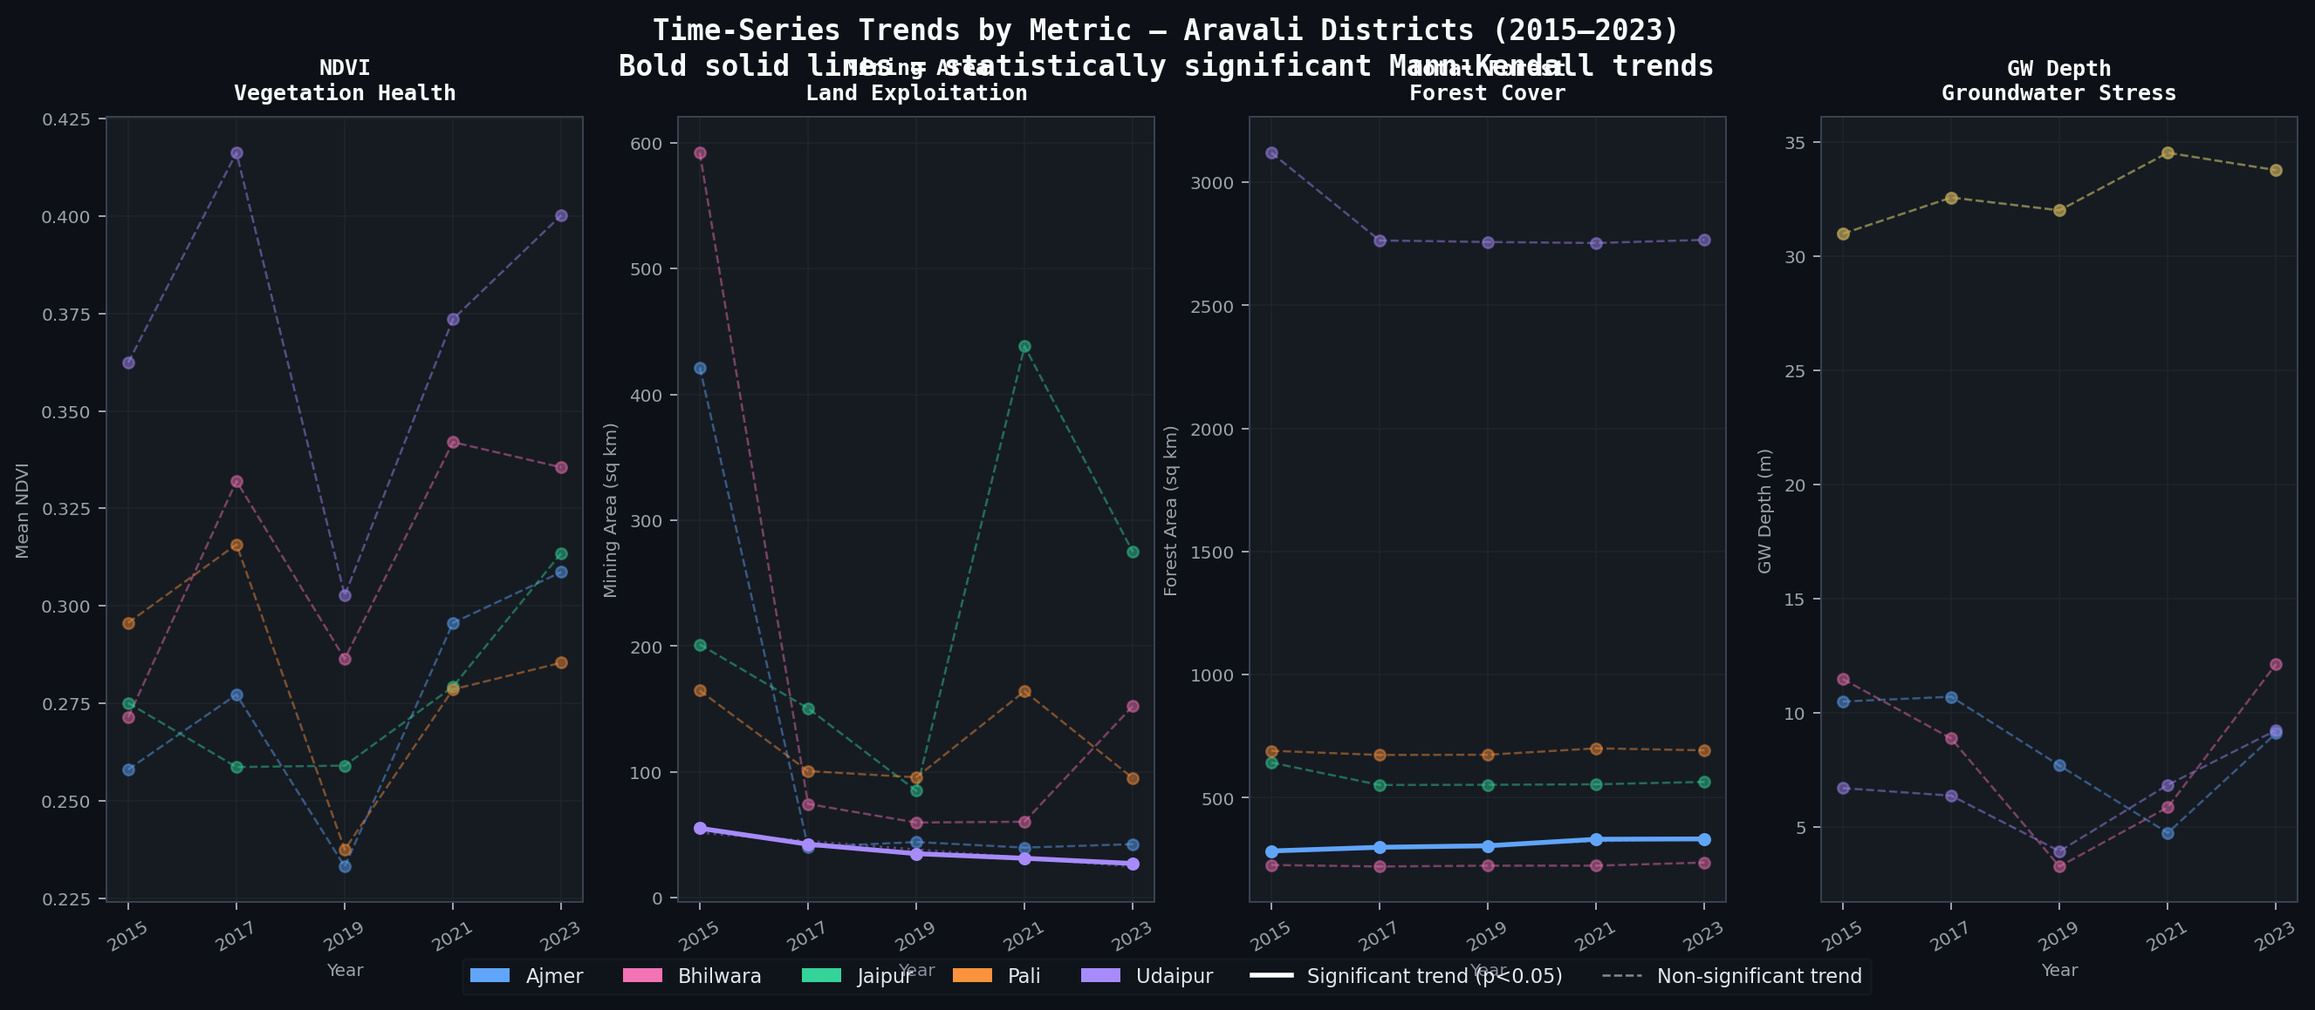
Figure 1: Time-series trends for all four key metrics across the five Aravali districts (2015–2023). Bold solid lines indicate statistically significant Mann-Kendall trends.

Jaipur shows a notable mining surge in 2021 (438.2 sq km) followed by partial contraction in 2023. Bhilwara's 2015 mining peak (591.9 sq km) is visible as a single-year anomaly, consistent with regulatory action or site exhaustion. Udaipur demonstrates consistently low mining activity and the highest NDVI values across the study period.

5.3 Groundwater Depth Trajectories
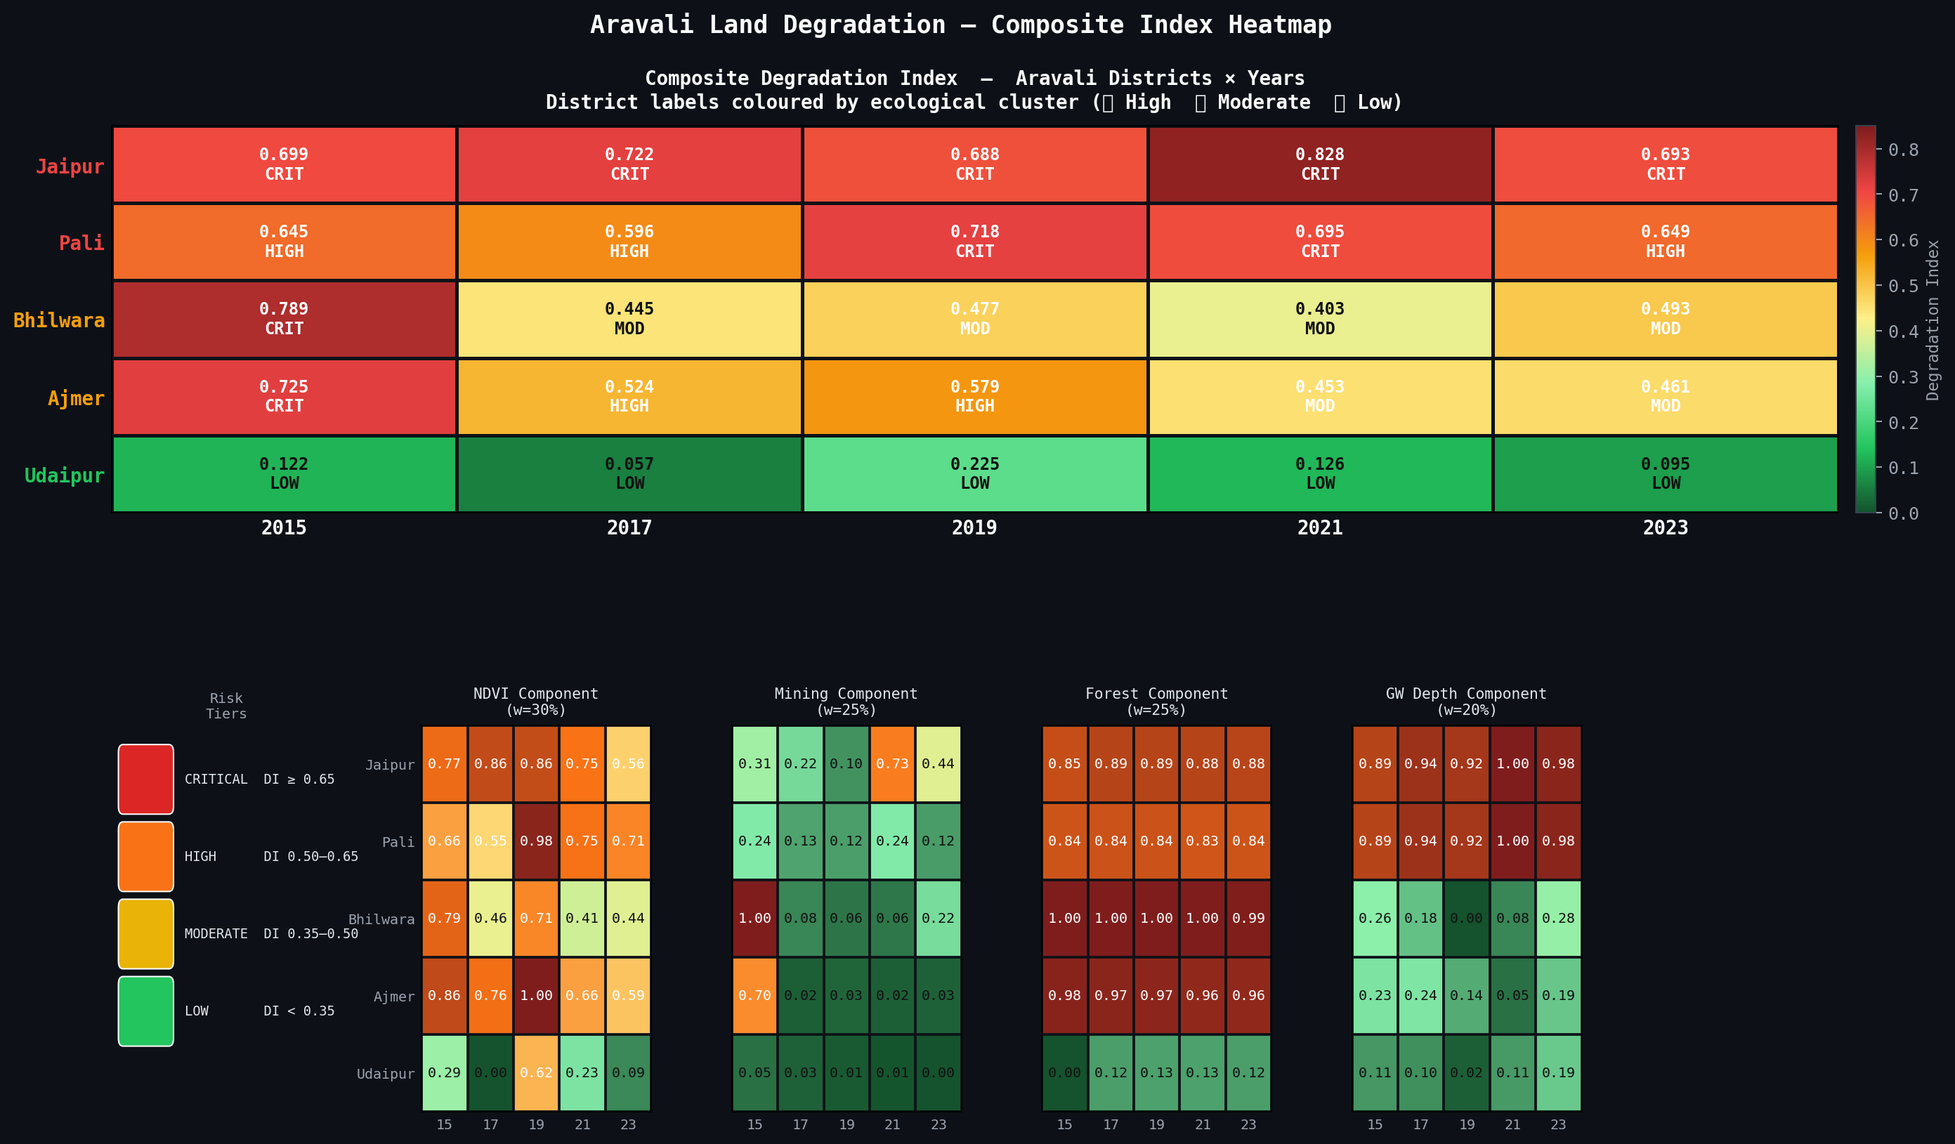
Figure 2: Composite Degradation Index heatmap across all districts and years. The persistent red colouring for Jaipur and Pali reflects chronic high-degradation status driven primarily by deep groundwater stress.

Jaipur and Pali share almost identical groundwater depth profiles across all five years, both consistently exceeding 30 metres depth — the GW stress threshold applied in this study. This is likely attributable to shared aquifer systems and monitoring station proximity. Udaipur maintains the shallowest groundwater, reflecting its greater forest cover and hydrological recharge capacity.

6. Advanced Analysis (Deliverable 2)

6.1 Mann-Kendall Trend Analysis
The Mann-Kendall test is a non-parametric rank-based method for detecting monotonic trends in time-series data, particularly suited for environmental datasets with non-normal distributions and potential outliers. It was implemented from scratch without external libraries, using the standard formulation:

S = Σ sign(xⱼ − xₖ) for all j > k
τ = S / [n(n−1)/2] | Var(S) = n(n−1)(2n+5) / 18

P-values were computed using a manual approximation of the standard normal CDF (Abramowitz & Stegun rational approximation). With n = 5 time points per series, the critical value |S| = 10 (τ = ±1.0) is required for significance at α = 0.05.

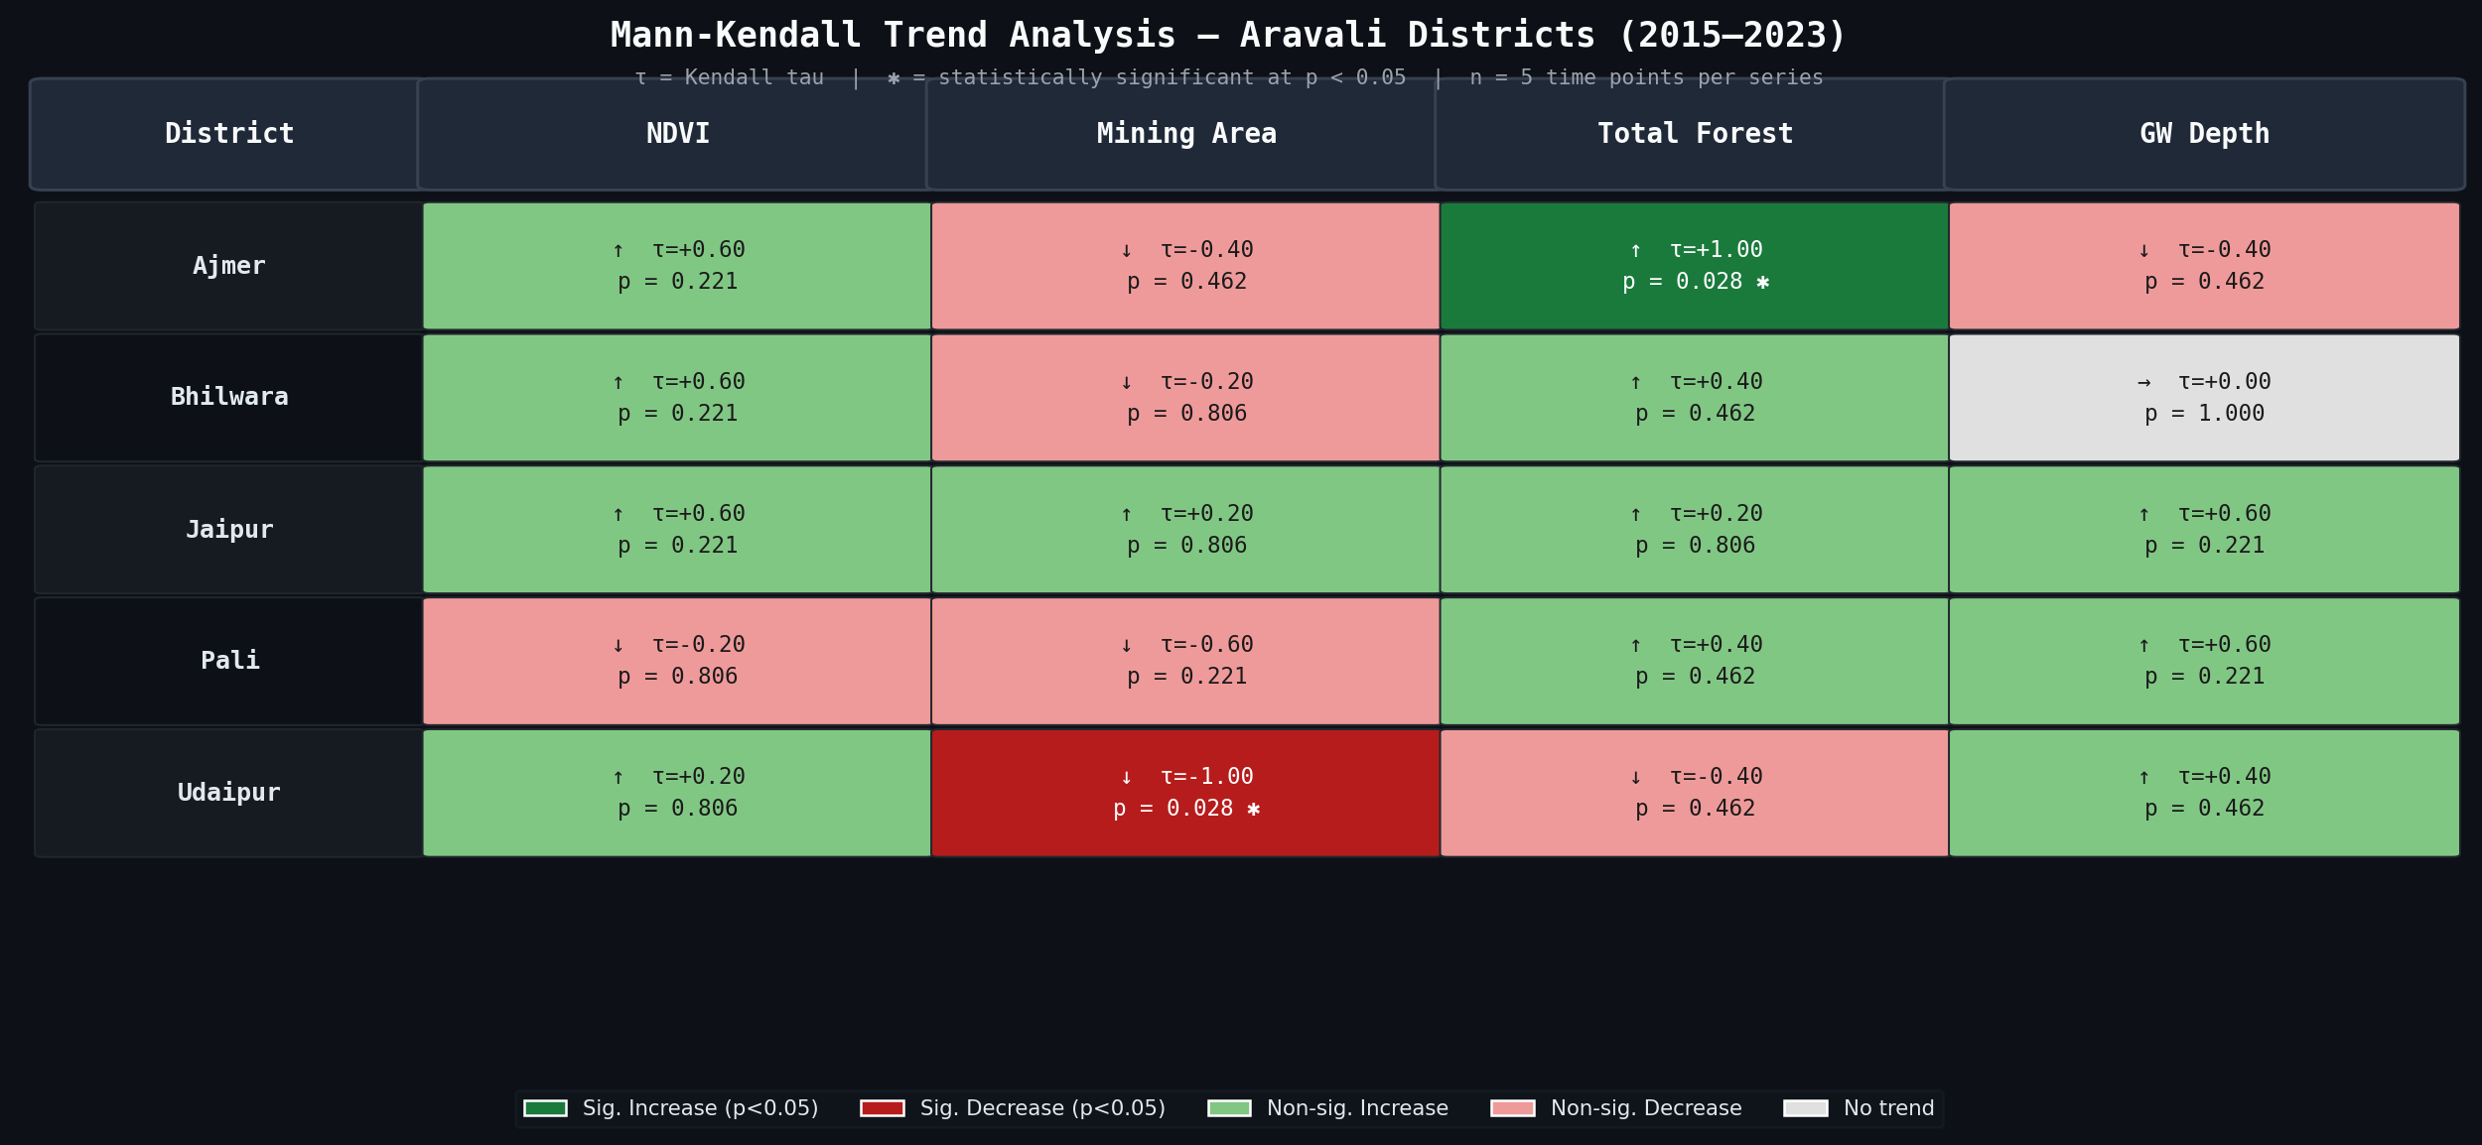
Figure 3: Mann-Kendall summary table — trend direction, Kendall tau, and p-value for all 20 district-metric combinations. Gold-bordered cells indicate statistical significance (p < 0.05).

6.1.1 Key Findings
District | Metric | Kendall τ | p-value | Interpretation
Ajmer | Total Forest | +1.000 | 0.027 | ✅ Significant: Perfect monotonic forest growth (+17.3% by 2023)
Udaipur | Mining Area | −1.000 | 0.027 | ✅ Significant: Perfect monotonic mining contraction (−50.6%)
Jaipur | GW Depth | +0.600 | 0.221 | Non-sig: Strong increasing trend — deepening aquifer stress
Pali | Mining Area | −0.600 | 0.221 | Non-sig: Consistent mining reduction but not perfectly monotonic
Bhilwara | GW Depth | 0.000 | 1.000 | No trend: GW fluctuates without directional pattern

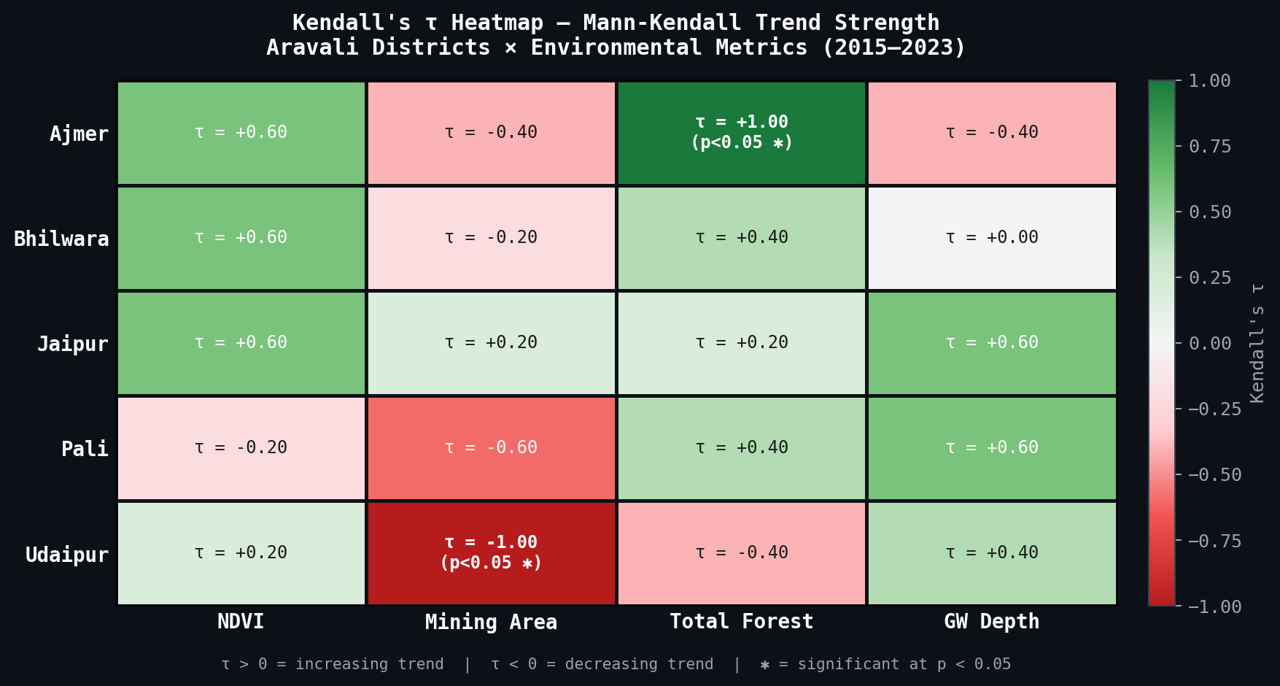
Figure 4: Kendall tau heatmap — shows trend strength and direction across all district-metric combinations. Cells marked with ✱ are statistically significant at p < 0.05.

The limited statistical power of Mann-Kendall with n = 5 is an acknowledged limitation. Significance is only achievable when the trend is perfectly monotonic (all 10 pairwise comparisons concordant). Non-significant results in this context do not imply absence of trend; rather, they reflect the mathematical constraints of small samples. The ecological interpretation of Kendall tau values — particularly τ = +0.6 for Jaipur GW depth and Pali GW depth — is substantively meaningful even without formal significance.

6.2 Pearson Correlation and OLS Regression
Ordinary Least Squares (OLS) regression was implemented from scratch using the standard closed-form solution for simple linear regression, without reliance on scipy or scikit-learn. P-values for regression coefficients were computed using a manual t-distribution CDF approximation via continued fraction expansion.

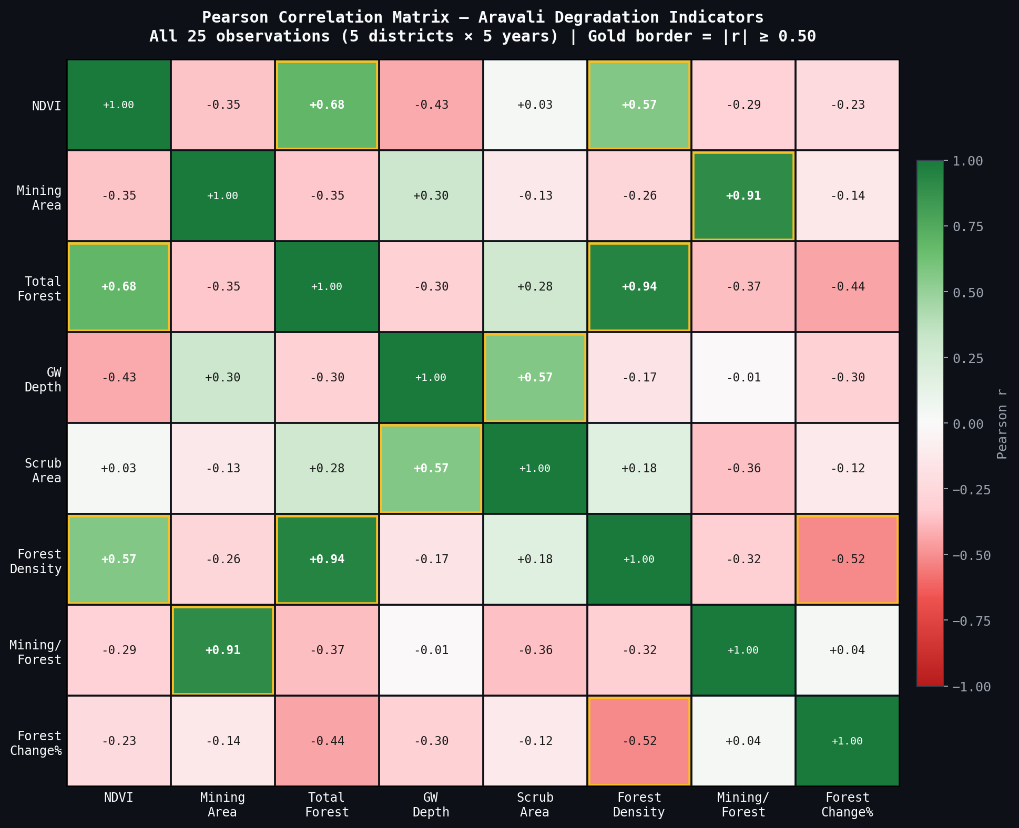
Figure 5: Pearson correlation matrix across eight environmental indicators. Gold borders highlight correlations with |r| ≥ 0.50.

6.2.1 Key Correlations
Variable Pair | Pearson r | R² | p-value | Significance
Total Forest → NDVI | +0.683 | 0.467 | 0.0002 | ✅ Significant
Mining Area → NDVI | −0.352 | 0.124 | 0.085 | Non-significant
Mining Area → GW Depth | +0.300 | 0.090 | 0.145 | Non-significant
Forest Density → NDVI | +0.568 | 0.323 | < 0.01 | ✅ Significant
Total Forest ↔ Forest Density | +0.943 | 0.889 | < 0.001 | ✅ Very strong

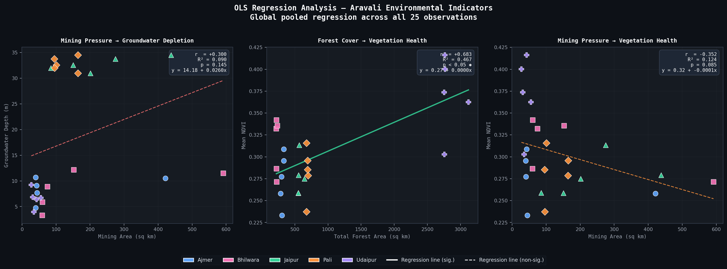
Figure 6: Three OLS regression panels — Mining Area → GW Depth (left), Total Forest → NDVI (centre), Mining Area → NDVI (right). District colour-coding shows that pooled correlation is partly driven by the Udaipur outlier effect.

The Forest → NDVI relationship is the strongest and most ecologically meaningful finding from regression analysis, explaining 46.7% of NDVI variance globally (R² = 0.467, p = 0.0002). This confirms that structural forest cover — not merely vegetation greenness — is the primary predictor of ecosystem health in the Aravali region.

The weak Mining → GW correlation (r = +0.300) at the pooled level is explained by structural confounding: Jaipur and Pali maintain deep groundwater (30–35 m) due to urban extraction pressure, independent of mining area. Within-district regression for Jaipur alone yields r = +0.773, the strongest single-district mining-groundwater relationship in the dataset.

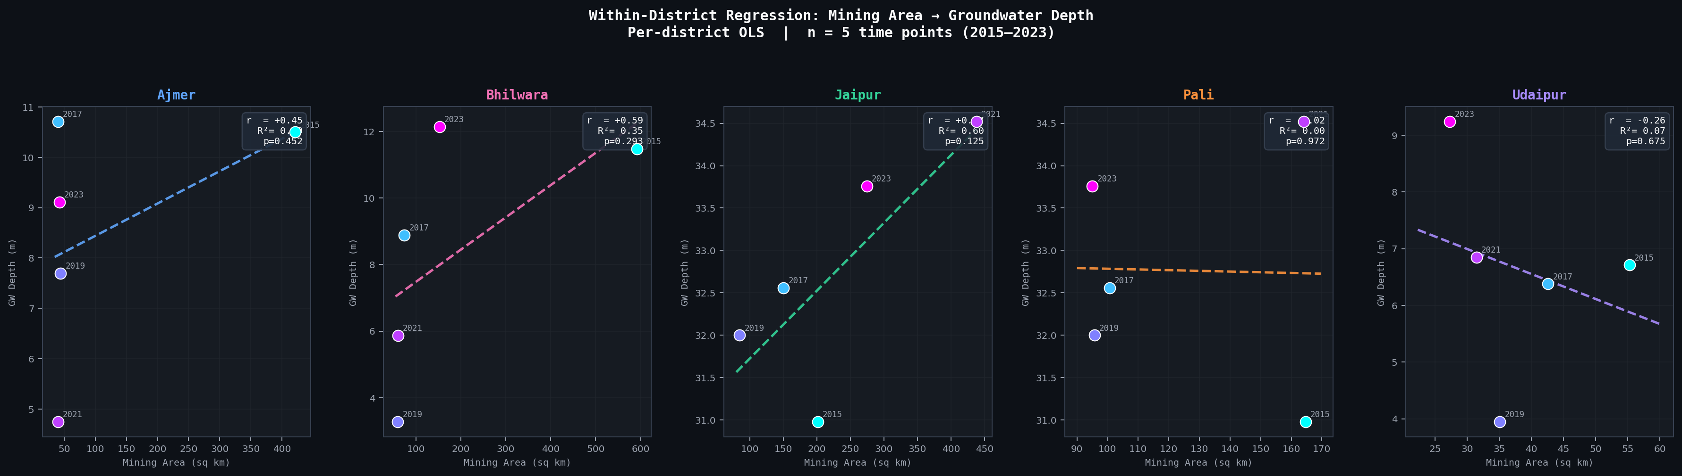
Figure 7: Within-district OLS regression for Mining Area → GW Depth (n=5 per district). Year labels show temporal context. Jaipur shows the strongest single-district relationship (r = +0.773).

6.3 K-Means Clustering and Manual PCA
K-Means clustering was applied to a district-level feature matrix comprising eight change-rate and level indicators: percentage change in NDVI, Mining Area, Forest Cover, and Groundwater Depth (2015–2023), plus mean NDVI, mean Mining/Forest Ratio, mean Forest Density Score, and GW Stress Years. All features were Z-score standardised prior to clustering.

Both K-Means and PCA were implemented from scratch. K-Means used 100 random restarts with K-Means++ initialisation to avoid local minima. PCA used power iteration eigendecomposition of the covariance matrix followed by deflation for subsequent components.

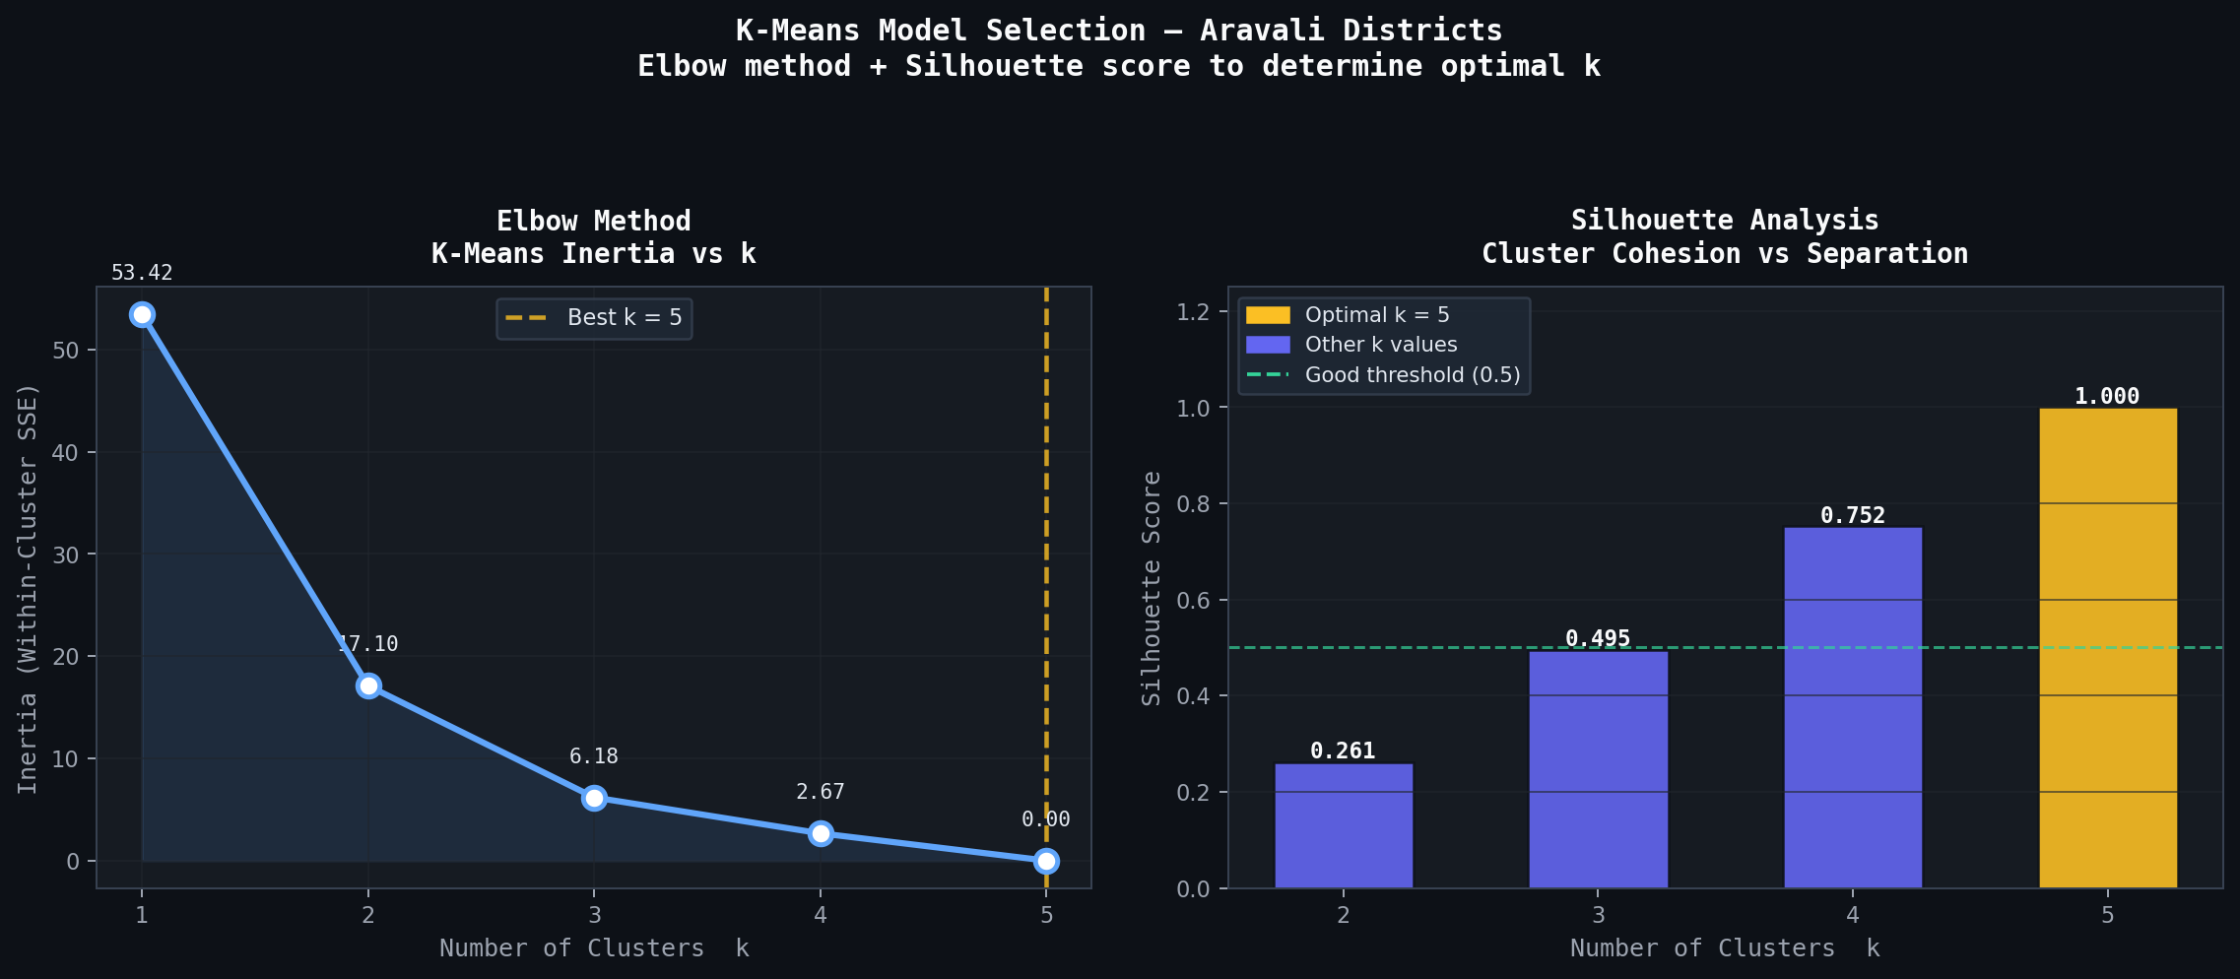
Figure 8: Elbow method (left) and silhouette score analysis (right) for k=1 to k=5. k=3 was selected as the optimal ecological partition based on interpretability, as k=4 and k=5 produce singleton clusters with n=1 districts.

6.3.1 Cluster Assignments (k=3)
Cluster | Ecological Label | Districts | Defining Characteristics
Cluster 1 | HIGH DEGRADATION | Jaipur, Pali | GW Stress: 5/5 years; Mean GW: 32.8 m; Forest loss; Silhouette: strong separation
Cluster 2 | LOW STRESS / RECOVERING | Udaipur | Mean NDVI: 0.371 (highest); Mining declining (τ=−1.0); 3,120 sq km forest baseline
Cluster 3 | MODERATE STRESS | Ajmer, Bhilwara | GW Stress: 0/5 years; Forest recovering in Ajmer (+17%); High historical mining in Bhilwara

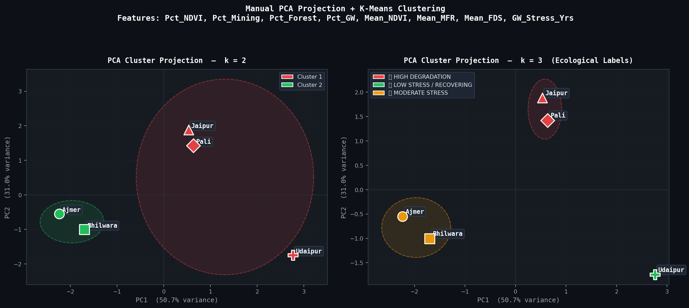
Figure 9: Manual PCA projection of five districts onto two principal components (81.7% combined variance). k=2 (left) and k=3 (right) cluster boundaries shown with ellipses.

PC1 (50.7% variance) primarily captures forest scale and NDVI level, separating Udaipur (rightmost) from the remaining four districts. PC2 (31.0% variance) captures change dynamics and GW stress, differentiating Jaipur and Pali (top) from Ajmer and Bhilwara (bottom-left). The PCA space confirms that districts with high degradation cluster in the upper-middle region, while the low-stress cluster (Udaipur) occupies a distinctly isolated position.

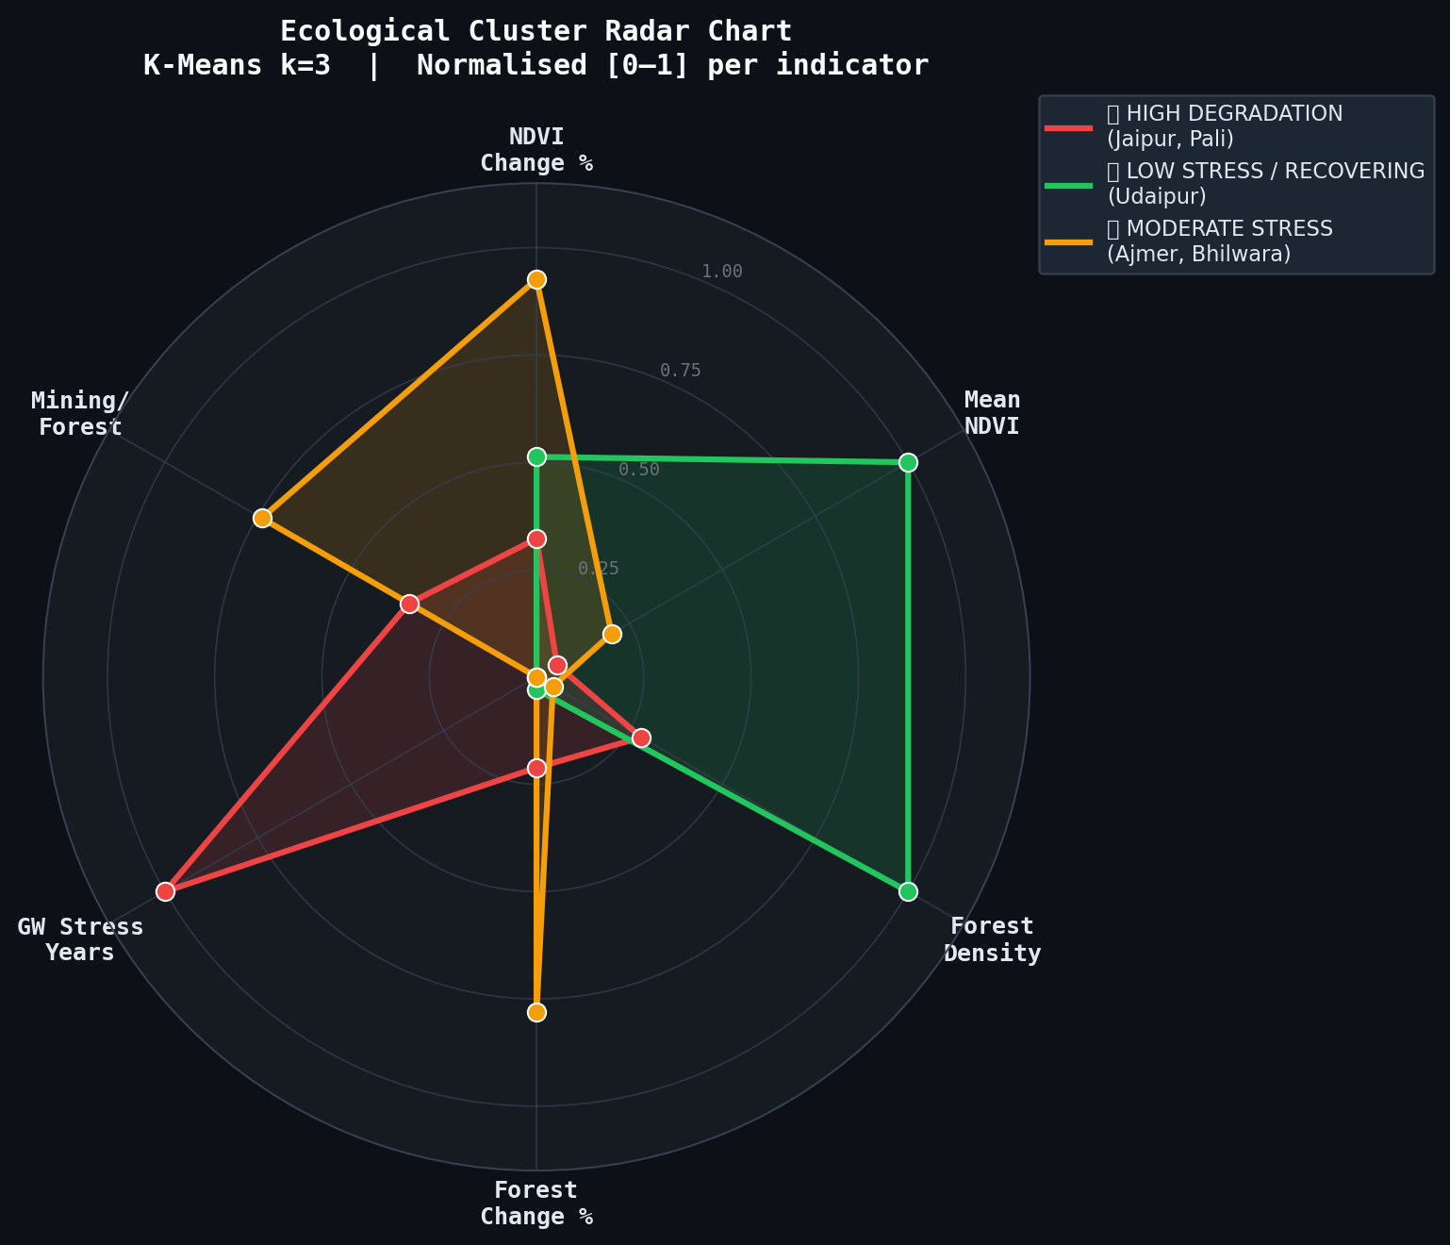
Figure 10: Radar chart showing normalised cluster profiles across six key indicators. The HIGH DEGRADATION cluster (red) shows elevated GW stress and mining/forest pressure; the LOW STRESS cluster (green) dominates in NDVI and forest density.

6.4 Composite Degradation Index
The Composite Degradation Index (DI) synthesises all four environmental pillars into a single scalar score per district per year, enabling direct cross-district comparison and temporal tracking of degradation trajectories. The index is aligned with the UNCCD Land Degradation Neutrality (LDN) framework weighting approach.

6.4.1 Construction Methodology
Component | Raw Metric | Normalisation | Weight | Rationale
DI_NDVI | Mean NDVI | 1 − min-max(NDVI) | 30% | Direct vegetation health signal; primary indicator of ecosystem function
DI_Mining | Mining Area (sq km) | min-max(Mining) | 25% | Active anthropogenic disturbance; reversible with enforcement
DI_Forest | Total Forest (sq km) | 1 − min-max(Forest) | 25% | Structural ecosystem component; slow recovery time
DI_GW | GW Depth (m) | min-max(GW_Depth) | 20% | Lagged subsurface consequence; hardest to reverse

All components are normalised to [0, 1] using global min-max scaling across all 25 observations, ensuring cross-district comparability. DI = 0.30 × DI_NDVI + 0.25 × DI_Mining + 0.25 × DI_Forest + 0.20 × DI_GW.

6.4.2 Risk Tier Classification
Tier | DI Range | Colour Code | Observations | Interpretation
CRITICAL | ≥ 0.65 | Red | 9 / 25 (36%) | Severe multi-indicator stress; urgent intervention required
HIGH | 0.50 – 0.65 | Orange | 5 / 25 (20%) | Multiple degradation pressures; monitoring essential
MODERATE | 0.35 – 0.50 | Yellow | 6 / 25 (24%) | Active degradation; preventive management recommended
LOW | < 0.35 | Green | 5 / 25 (20%) | Ecosystem relatively intact; sustain conservation measures

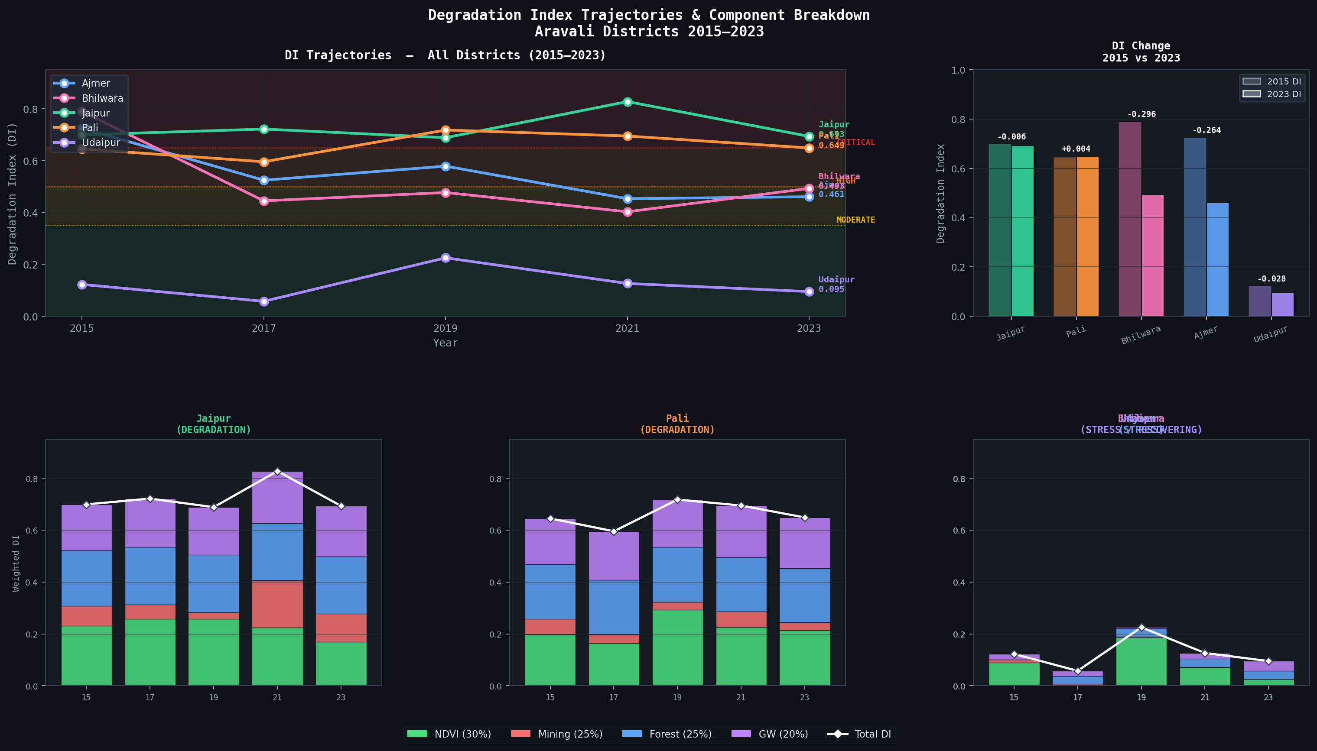
Figure 11: DI trajectories for all five districts (2015–2023), with stacked component breakdown per district shown in bottom panels. Risk threshold lines at DI = 0.35, 0.50, and 0.65 are overlaid.

6.4.3 2023 Risk Ranking
Rank | District | DI 2023 | Risk Tier | Trend 2015→2023 | Cluster
1 | Jaipur | 0.6934 | CRITICAL | → Stable (Δ = −0.006) | HIGH DEGRADATION
2 | Pali | 0.6488 | HIGH | → Stable (Δ = +0.004) | HIGH DEGRADATION
3 | Bhilwara | 0.4930 | MODERATE | ▼ Improving (Δ = −0.296) | MODERATE STRESS
4 | Ajmer | 0.4607 | MODERATE | ▼ Improving (Δ = −0.264) | MODERATE STRESS
5 | Udaipur | 0.0949 | LOW | ▼ Improving (Δ = −0.028) | LOW STRESS / RECOVERING

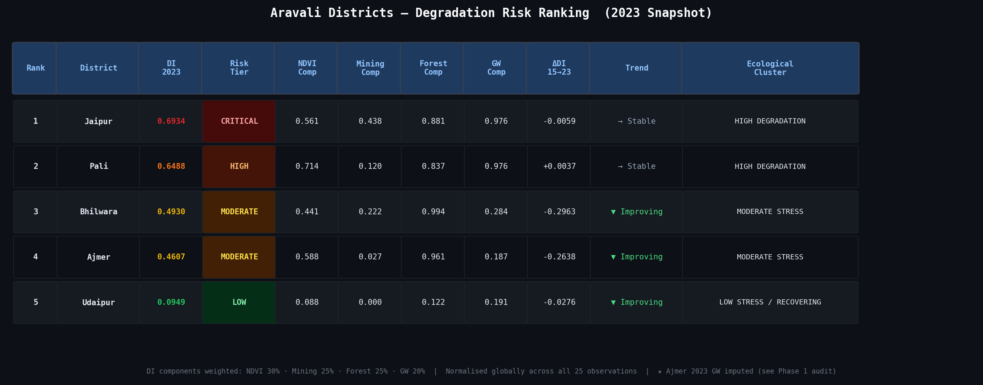
Figure 12: Final risk ranking table showing 2023 DI scores, risk tiers, component contributions, and trajectory trends for all five districts.

Jaipur's structural lock-in to CRITICAL status is driven by its GW component consistently scoring 0.886–1.000 across all five years — the highest in the dataset — reflecting the chronic 30–35 m depth-to-water-table that persists regardless of forest or mining improvements. Bhilwara's dramatic improvement from CRITICAL (2015) to MODERATE (2023) is attributable entirely to the collapse of its 2015 mining anomaly (591.9 sq km → 152.5 sq km by 2023). Udaipur's stable LOW status confirms it as the ecological anchor of the region.

7. Scalability, Memory, and Performance

7.1 Current System Profile
The current implementation operates on a deliberately constrained dataset: 5 districts × 5 biennial time points = 25 complete observations. All processing runs in-memory on a single machine using standard Python scientific computing libraries. Execution times are negligible (< 30 seconds end-to-end). The SQLite warehouse occupies less than 1 MB on disk.

Dimension | Current Scale | Bottleneck? | Notes
Districts | 5 | No | SQLite scales to thousands without modification
Years | 5 (biennial) | No | Annual data would add 9 more rows per district
Raster Files | 10 (5 NDVI + 5 LULC) | Yes at scale | Rasterstats is single-threaded; 30m rasters for 33 districts would require 20–30 minutes
Observations (ML) | 25 rows | Yes for deep learning | K-Means and OLS work well; insufficient for neural networks
Storage | < 1 MB (CSV+SQLite) | No | Raster TIFFs add 50–200 MB per image at Rajasthan scale

7.2 Identified Limitations
- n = 5 per time series: Mann-Kendall requires |S| = 10 (τ = ±1.0) for significance at α = 0.05. Expanding to annual data (n=9) would lower the significance threshold to |S| = 14, substantially increasing statistical power.
- Spatial resolution: 30m Landsat pixels may not capture fine-scale mining pit boundaries. Sentinel-2 (10m) would improve accuracy but increase data volume 9×.
- Jaipur/Pali GW data sharing: Both districts appear to draw from the same CGWB monitoring station, yielding identical GW values across all years. This confounds per-district analysis.
- Ajmer 2023 GW imputation: The anomalous 208.40 m value required imputation. The cause — likely a unit error in source data — could not be verified without raw station records.
- Clustering stability: K-Means on n=5 points is inherently unstable across k choices. The ecological interpretation of cluster boundaries should be treated as exploratory rather than definitive.

7.3 Future Scalability Pathway
7.3.1 Data Pipeline Scale-Up
- Replace Rasterstats with Google Earth Engine server-side zonal statistics — eliminates local raster download and processing entirely. GEE can process all 33 Rajasthan districts in parallel within minutes.
- Migrate SQLite to PostgreSQL with PostGIS extension for concurrent multi-user access, spatial indexing, and partitioned tables by year.
- Adopt Cloud-Optimised GeoTIFF (COG) format on AWS S3 / GCS for raster storage, enabling range-request-based sub-scene extraction without full file download.
- Implement Apache Airflow DAG for annual automated pipeline execution triggered by new FSI report release or CGWB data update.
7.3.2 Analysis Scale-Up
- With 33 districts × 20 years = 660 observations, Random Forest regression becomes viable for non-linear relationship modelling between mining, forest, NDVI, and GW.
- DBSCAN or hierarchical clustering would replace K-Means for district grouping, handling variable cluster shapes and automatically detecting the number of clusters.
- Time-series decomposition (STL) would separate seasonal from trend components in annual NDVI data, improving sensitivity to long-term degradation signals.
- Spatial autocorrelation analysis (Moran's I) would identify whether degradation clusters geographically — a critical input for targeted conservation policy.
7.3.3 Deployment Scale-Up
- The current HTML dashboard operates locally. Deploying to Hugging Face Spaces (free tier) or a FastAPI server would enable public access without infrastructure cost.
- A Gradio application wrapping the full analysis pipeline would enable non-technical users to upload their own district data and receive automated degradation assessments.

8. Interactive Analysis Dashboard
An interactive web-based dashboard was developed as the primary user interface for this project, replacing a server-dependent Gradio application (which requires internet access for installation) with a fully self-contained HTML file deployable in any modern browser without any installation or server infrastructure.

8.1 Technical Architecture
- Technology: Single-file HTML + CSS + JavaScript using Chart.js (CDN-loaded) for live chart rendering.
- Data: All 25 observations from aravali_clean.csv, all MK results from mk_results.csv, all cluster assignments, and all DI values are embedded directly in the JavaScript data layer.
- Analytics: Pearson correlation and OLS regression are computed client-side in real time using manual JavaScript implementations of the same algorithms used in the Python analysis.
- No server required: The file opens directly in any browser. All interactivity is local.

8.2 Dashboard Structure — Three Tabs
Tab 1: District Explorer
- Dropdown selectors for District (5 options) and Metric (NDVI / Mining / Forest / GW Depth).
- Four dynamic stat cards: 2023 metric value, 2015→2023 delta, DI score, and count of significant MK trends.
- Four Mann-Kendall trend cards per district showing trend direction, τ, p-value, and significance badge.
- Full interactive time-series chart overlaying all five districts, updated live on metric change.
- Four mini panels showing all four metrics simultaneously for the selected district.
Tab 2: Correlation Explorer
- X-axis and Y-axis dropdowns (6 metrics each) enabling any pairwise combination.
- District filter dropdown (All pooled or single-district subset).
- Live scatter plot with per-district colour/marker coding and regression line (solid = sig., dashed = non-sig.).
- Live regression statistics panel: β₀, β₁, Pearson r, R², and qualitative strength label — all computed in-browser.
- Bar chart showing Pearson r for all 6 predictors vs NDVI simultaneously.
- Full 6×6 correlation heat grid with gold borders for |r| ≥ 0.50.
Tab 3: Degradation Dashboard
- Three ecological cluster summary cards (HIGH / MODERATE / LOW) with key statistics.
- Year selector dropdown — filters entire dashboard view to selected year or shows all years.
- Interactive DI heatmap: districts × years, cell colour reflects risk tier, hover shows exact value.
- DI trajectory chart with all five district lines and risk threshold annotations.
- Stacked bar chart showing weighted component breakdown per district for selected year.
- Full sortable risk ranking table with tier badges, all four component values, and cluster assignment.

9. Key Findings and Conclusions

9.1 Summary of Findings
This study applied a multi-method analytical framework to characterise land degradation across five Aravali Hill districts in Rajasthan over the 2015–2023 period. The principal findings are:

- Jaipur is the most critically degraded district in the study region (DI = 0.693 in 2023, CRITICAL tier), with its status driven primarily by structural groundwater depletion (30–35 m depth across all observed years) rather than recent mining expansion. This degradation is chronic and shows no improving trajectory.
- Pali shares Jaipur's groundwater stress profile and high-degradation cluster membership, suggesting shared aquifer dynamics and similar structural risks despite lower mining activity.
- Bhilwara exhibited the sharpest improvement trajectory — from CRITICAL in 2015 (DI = 0.789, driven by a 591.9 sq km mining footprint) to MODERATE by 2017 — demonstrating that acute mining disturbance can contract rapidly when regulatory or market conditions change.
- Ajmer shows statistically significant forest growth (MK τ = +1.0, p = 0.027), the only case of confirmed ecological improvement in the dataset. Forest area grew 17.3% from 284 sq km in 2015 to 333 sq km in 2023.
- Udaipur is the ecological anchor of the Aravali region, maintaining consistently LOW degradation status (DI range: 0.057–0.225) anchored by its 3,120 sq km forest base and the only statistically confirmed positive trend: a perfect monotonic decline in mining activity (MK τ = −1.0, p = 0.027).
- Forest cover is the strongest individual predictor of ecosystem health: Total Forest → NDVI regression yields r = +0.683, R² = 0.467, and p = 0.0002 — the only globally significant regression in the study.
- K-Means clustering (k=3) successfully partitions the five districts into ecologically meaningful groups, with PCA confirming clean separation in two-dimensional space (81.7% combined variance explained).

9.2 Policy Implications
- Groundwater management in Jaipur and Pali requires immediate intervention. The chronic 30+ metre depth-to-water-table cannot be reversed through forest-only conservation; dedicated aquifer recharge programmes and urban extraction regulation are essential.
- Bhilwara's recovery trajectory demonstrates the effectiveness of mining regulation. Sustaining the post-2015 reduction in mining footprint should be a policy priority, with legal enforcement mechanisms to prevent reversion.
- Ajmer's forest recovery success should be documented and replicated. The mechanisms driving the +17.3% forest growth (whether natural regeneration, plantation, or fuelwood demand reduction) warrant further investigation and replication across the region.
- Udaipur's large forest reserve should be formally protected. Any mining expansion in Udaipur district would disproportionately threaten the region's only ecological resilience anchor.

9.3 Limitations and Future Work
The principal limitations of this study are the small temporal sample (n=5 per district), shared groundwater data for Jaipur and Pali, the imputed Ajmer 2023 GW value, and the absence of socioeconomic variables (population density, industrial output, water pricing) that would enable causal rather than correlational analysis.

Future work should: (a) extend temporal coverage to annual observations using GEE annual NDVI composites and annual CGWB district reports; (b) expand spatial coverage to all 33 Rajasthan districts; (c) incorporate Sentinel-2 10m imagery for improved mining boundary detection; and (d) develop a predictive degradation model using Random Forest regression on the expanded dataset.

9.4 Project Deliverables
Deliverable | Component | Status
Deliverable 1 | Geospatial ETL pipeline + SQLite star schema warehouse | Complete
Deliverable 1 | Fact tables: Dim_Time, Dim_Location, Fact_Degradation, Fact_Land_Distribution | Complete
Deliverable 1 | Exploratory analysis: NDVI trends, forest cover, GW trajectories, mining area | Complete
Deliverable 2 | Mann-Kendall trend analysis (manual implementation, n=20 tests) | Complete
Deliverable 2 | OLS regression analysis (manual implementation, 3 primary regressions) | Complete
Deliverable 2 | K-Means clustering + manual PCA (manual implementation, k=2,3) | Complete
Deliverable 2 | Composite Degradation Index (25 observations, 4 components, 4 risk tiers) | Complete
Deliverable 2 | Interactive HTML dashboard (3 tabs, live charts, all data embedded) | Complete
Deliverable 2 | Scalability and performance analysis | Complete
Deliverable 2 | Combined academic report (this document) | Complete

END OF REPORT
Aravali Hills Land Degradation Analysis · Rajasthan, India · 2015–2023

